SEOUL BIKE RENTALS
2018 Rental Analysis (1 January to 30 November)
Months, seasons, hours, weekdays, weather, holidays and the winter comparison, with four recommendations

Summary
Seoul Bike Rentals recorded 5,986,984 rentals on 322 open dates from 1 January to 30 November 2018, a mean of 18,593 per day. Demand follows the seasons. Summer leads at 24,818 rentals per day and Winter trails at 5,116, 79% lower. Demand means completed rentals. The data holds no record of requests that went unmet.
Total Rentals  5,986,984  322 open dates | Mean per Day  18,593  rentals | Busiest Day  36,149  Wed 13 Jun | Quietest Day  977  Mon 23 Apr | Summer to Winter  −79%  mean per day

- Months: June peaks at 29,896 rentals per day and January is lowest at 4,839. March posted the biggest rise, +126%, in February.

- Seasons: Summer (24,818) leads Autumn (22,099), Spring (17,910) and Winter (5,116). Spring is the least steady season, with a spread of 47% of its mean.

- Hours: Weekdays peak at 8:00 (1,425 per hour) and 18:00 (1,865). Weekends and holidays peak once, at 17:00. The evening block (16:00 to 20:00) holds 35% of rentals.

- Days: Friday is the strongest weekday at 19,798 rentals per day. Sunday is the weakest day on 16,528 and is the lowest day in 14 of 40 complete weeks.

- Weather: Temperature shows r = +0.72 across the year, mostly because seasons differ. Inside Summer it turns to −0.22. Rain days run 14% to 46% below dry days.

- Holidays and closures: 10 of 16 open holidays fall below ordinary dates in their month. The center closed on 12 dates, 10 of them from September to November.

- Winter against December: Winter 2018 averages 5,116 rentals per day against 5,978 in December 2017, a gap of 14.4%. The gap is borderline (2.1 standard errors), and weather does not explain it.

- Evidence limits: One year of data, no operations, station or revenue records, and no record of unmet demand. The recommendations test causes and do not assume them.

Data Audit and Definitions

Data Audit
The audit checked the 2018 slice of the source file before any analysis. Notebook 03_audit_2018 holds the full checks.
Check | Results
Source file and date range | SeoulBikeData.csv, 1 January 2018 to 30 November 2018
Records in scope | 7,721 open rows across 322 dates
Hours per date | 24 rows on all dates except 6 October (17 rows)
Missing values | 0
Duplicate rows | 0 (no repeated date and hour pair)
Closed hours | 295 rows in the raw file. 12 dates are closed all day, and 6 October has 7 closed hours. Closed rows stay out of the analysis table
Rentals per hour | Lowest 2, highest 3,556
Dates by season | Winter 59, Spring 90, Summer 92, Autumn 81
Holiday flag | The source flags 13 dates. This report uses 16 verified open holiday dates and 1 closed holiday (9 October). The raw flag is not used
Table 2.1: Data Audit

Data Definition
Term | Definition
Mean rentals per day | Total rentals divided by open dates in the period.
Week | Runs Friday to Thursday, anchored on Friday 1 December 2017. Week 5 holds Monday 1 January to Thursday 4 January 2018 and is partial. 40 of 49 weeks in 2018 are complete.
Weekday, Weekend, Holiday | Weekends are Saturday and Sunday. Holiday is a verified public holiday. A weekend holiday counts as Holiday only. 217 weekdays, 89 weekend dates and 16 holiday dates are open.
Closed date | A calendar date with no open hours. 12 dates in 2018.
Partial date | An open date with fewer than 24 open hours. 6 October has 17.
Time blocks | Night 0 to 5, Morning 6 to 9, Midday 10 to 15, Evening 16 to 20, Late 21 to 23.
Peers | Ordinary dates in the same month with the same weekday type as a holiday. Used to judge a holiday against its own season.
Rain day | A date with any rainfall recorded in its 24 hours.
Spread | Standard deviation as a share of the mean.
Correlation (r) | Runs from −1 to +1. The value r squared gives the share of variation explained. With 59 dates |r| needs about 0.26 to separate from chance, with 92 dates about 0.21.
Table 2.2: Data Definitions

Business Questions and Findings
Question 1: How much demand did 2018 hold and which days stand out?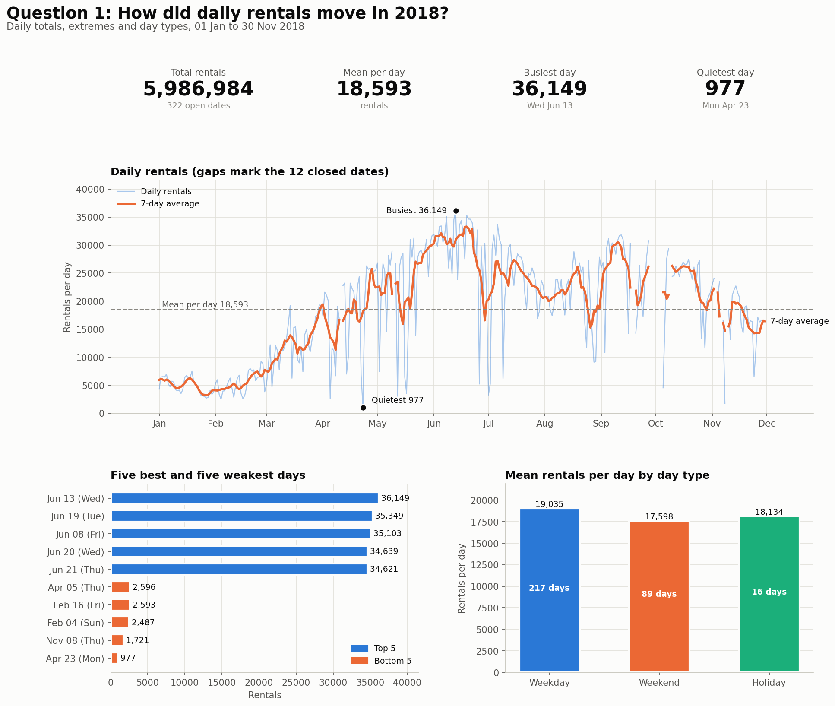
Figure 1. Daily rentals, 2018.
- 2018 had 5,986,984 rentals over 322 open dates, a mean of 18,593 per day. The median is 20,475. The mean sits below the median because Winter dates pull it down.

- The busiest day was Wednesday 13 June with 36,149 rentals. It was a holiday (local election day). The quietest was Monday 23 April with 977.

- All five busiest days fall in June. The peak-to-trough drop is 97% (36,149 to 977). Two dates set this figure, so it shows range and not direction.

- The standard deviation is 9,691 rentals per day, 52% of the mean. Season alone explains 51% of the variation between dates.
- The 7-day average peaks at 33,297 on 19 June and bottoms at 3,167 on 27 January.

- Day types average 19,035 (Weekday, 217 dates), 17,598 (Weekend, 89) and 18,134 (Holiday, 16). These means mix seasons, so Question 7 judges holidays against peers.

- The center closed on 12 dates. They stay empty and do not count as zero. 6 October holds 17 open hours.

One-liner Insight: Demand built from January to a June peak, then eased through the second half with a September rebound. The range is wide, with two dates setting both extremes. Season explains about half of it.

Question 2: How does demand change from month to month?
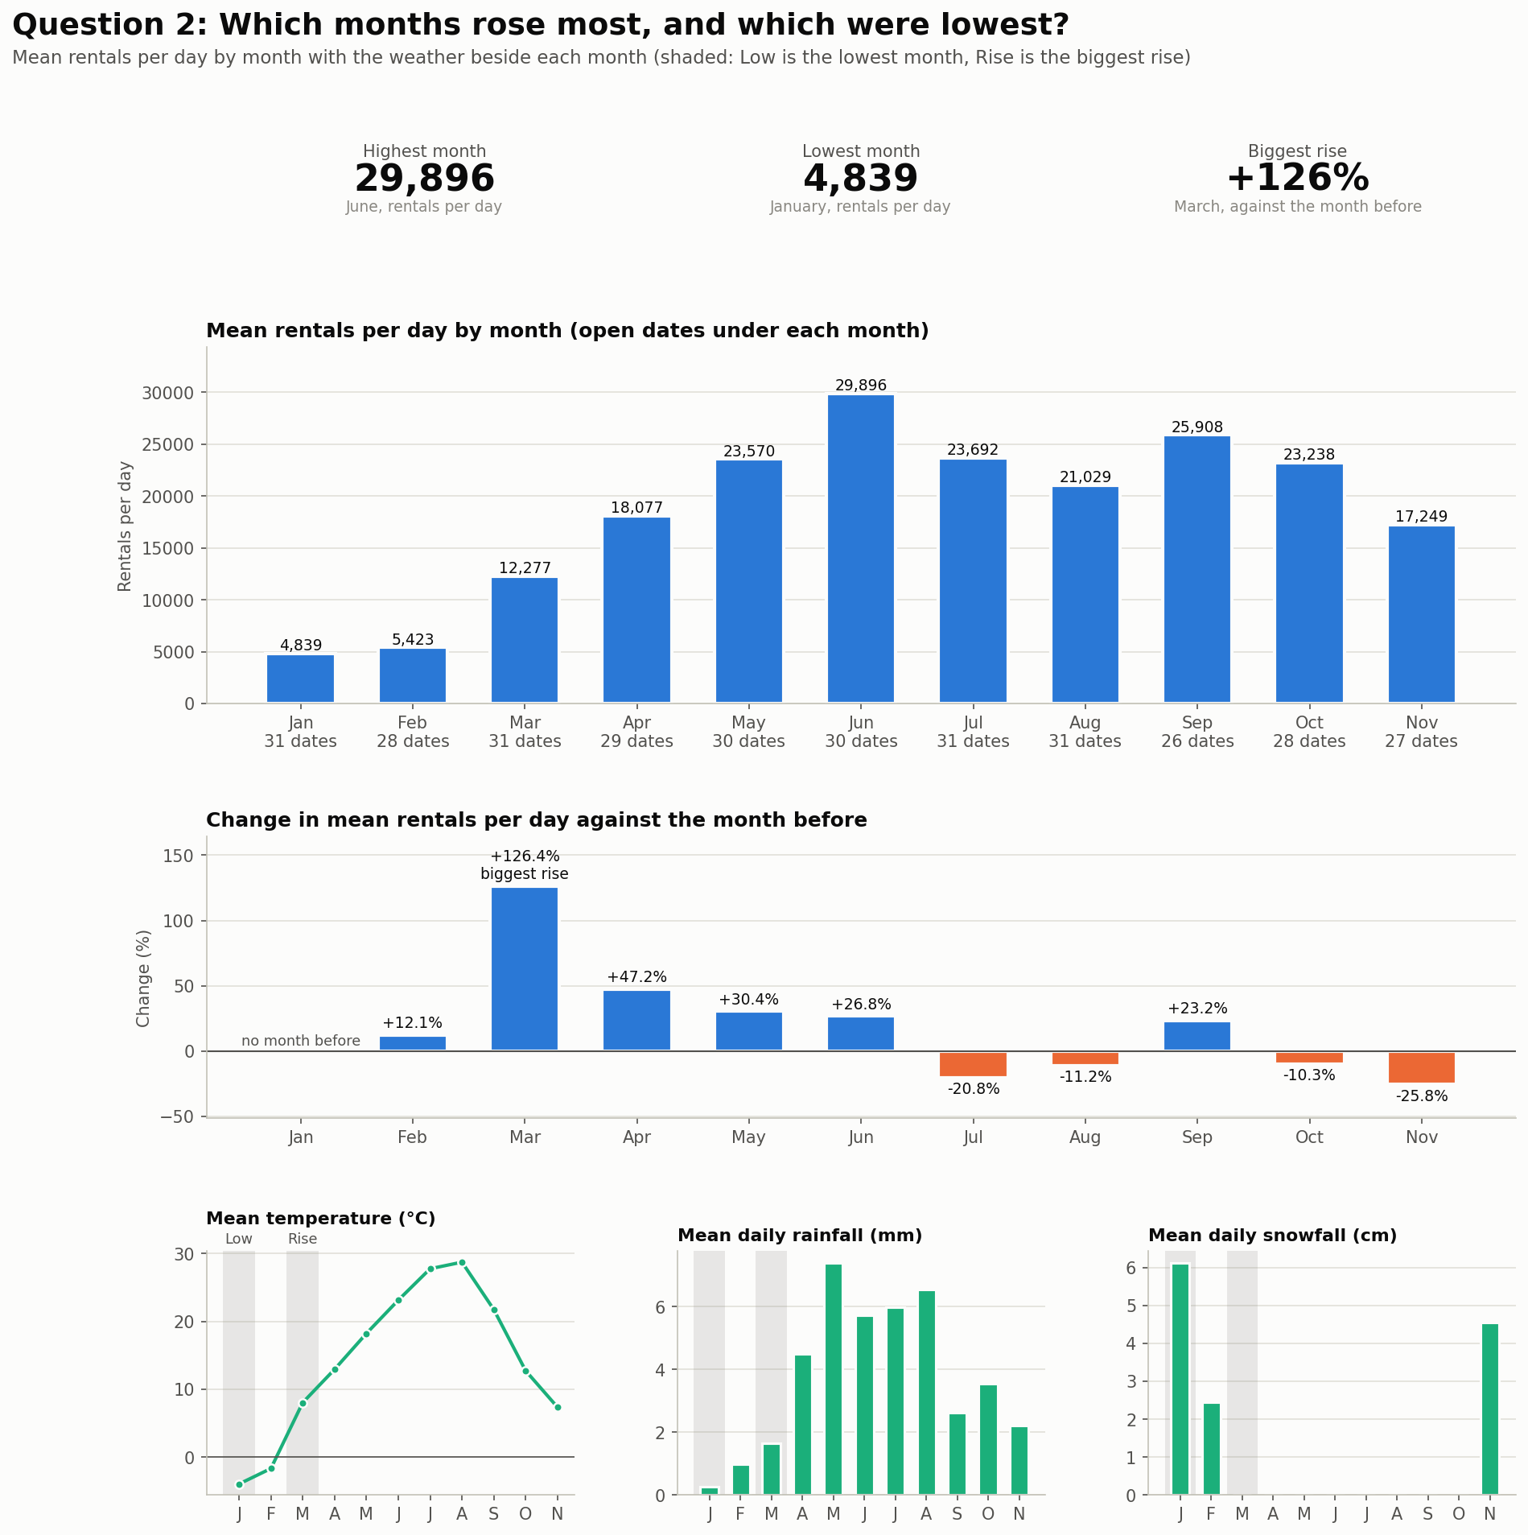
Figure 2. Mean rentals per day by month, 2018.

Month | Open Dates | Mean per Day | Change | Temperature (°C) | Rainfall (mm/day) | Snowfall (cm/day)
January | 31 | 4,839 | n/a | −3.9 | 0.27 | 6.13
February | 28 | 5,423 | +12% | −1.7 | 0.99 | 2.45
March | 31 | 12,277 | +126% | 8.0 | 1.66 | 0.00
April | 29 | 18,077 | +47% | 13.0 | 4.49 | 0.00
May | 30 | 23,570 | +30% | 18.2 | 7.40 | 0.00
June | 30 | 29,896 | +27% | 23.1 | 5.72 | 0.00
July | 31 | 23,692 | −21% | 27.8 | 5.99 | 0.00
August | 31 | 21,029 | −11% | 28.7 | 6.54 | 0.00
September | 26 | 25,908 | +23% | 21.7 | 2.63 | 0.00
October | 28 | 23,238 | −10% | 12.7 | 3.55 | 0.00
November | 27 | 17,249 | −26% | 7.4 | 2.23 | 4.56
Table 3.1: Weather Table by Month

- June leads at 29,896 rentals per day. January is lowest at 4,839, at −3.9 C with 6.13 cm of snow per day.

- March posted the biggest rise, +126.4% on February, at 8.0 C with no snow.

- The warmest months do not lead. June averaged 23.1 C. August averaged 28.7 C and fell to 21,029.

- After June demand fell in July (−21%) and August (−11%), rose in September (+23%, 25,908) and fell again in October (−10%) and November (−26%).

- September, October and November hold 26, 28 and 27 open dates because of closures. Month means rest on fewer dates there.

- The table shows association and not cause. Rain, seasons and holidays also differ by month. Question 6 tests the weather link inside each season.

One-liner Insights: Demand rises from a January low to a June peak, dips in July and August, recovers in September and falls through autumn. Heat alone does not decide the peak month.

Question 3: Which season leads and how steady is each?
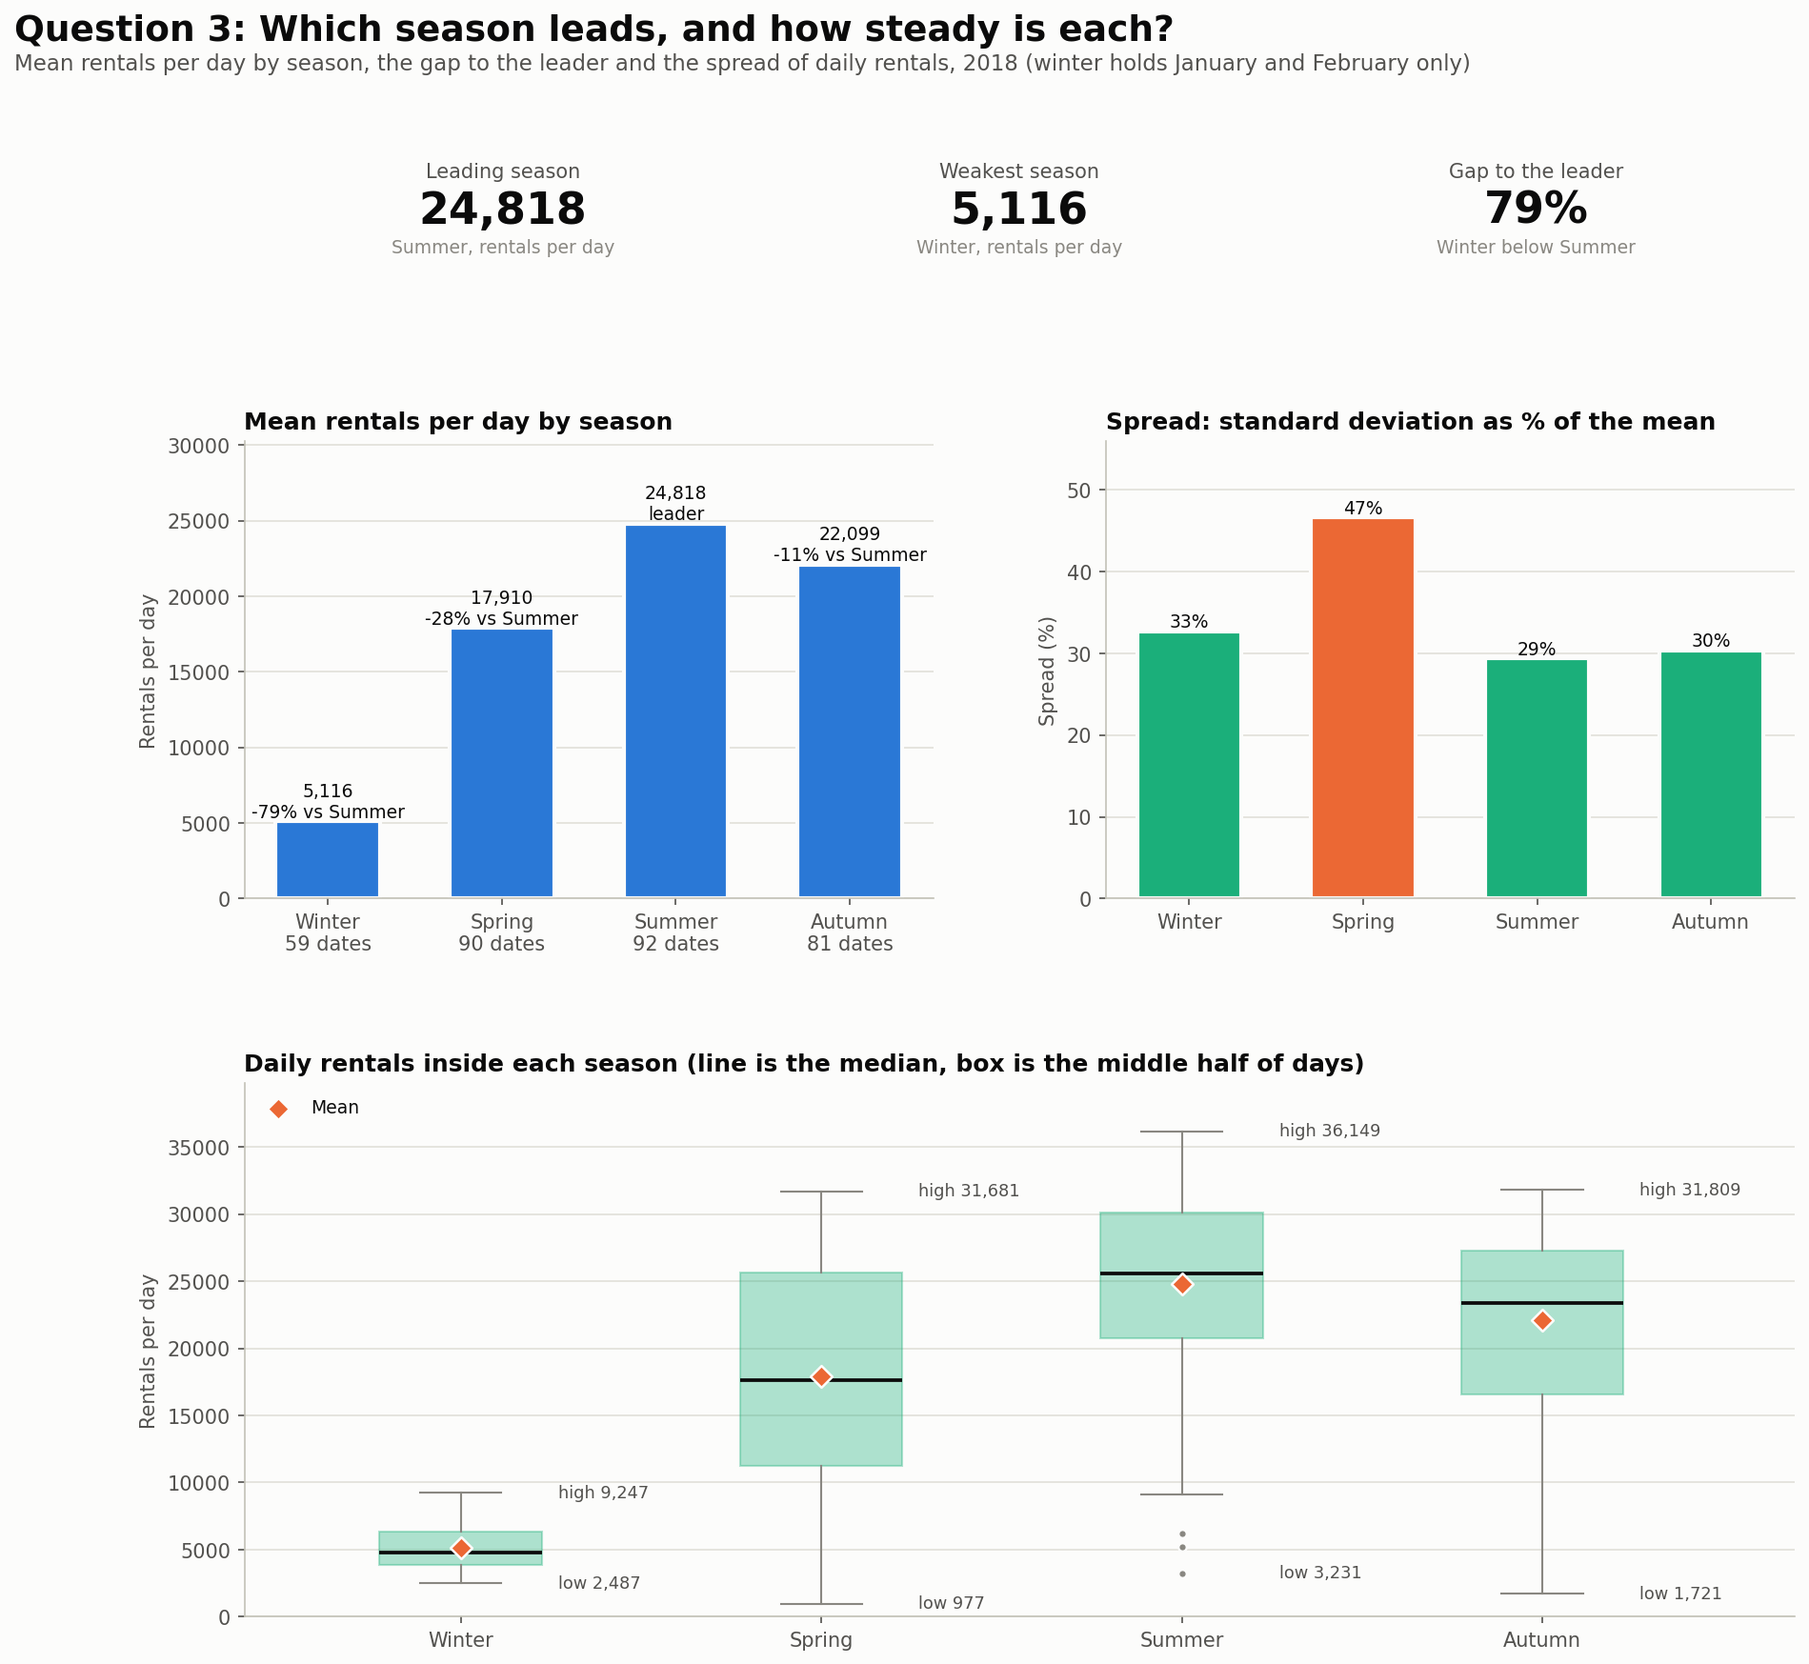
Figure 3. Mean rentals per day by season and spread, 2018.
Seasons | Open Dates | Mean per Day | Median | Lowest | Highest | Spread | Gap to Summer
Winter | 59 | 5,116 | 4,813 | 2,487 | 9,247 | 33% | −79%
Spring | 90 | 17,910 | 17,590 | 977 | 31,681 | 47% | −28%
Summer | 92 | 24,818 | 25,572 | 3,231 | 36,149 | 29% | leader
Autumn | 81 | 22,099 | 23,350 | 1,721 | 31,809 | 30% | −11%
Table 3.2: Seasonal Table

- Summer leads with 24,818 rentals per day, followed by Autumn at 22,099, Spring at 17,910 and Winter at 5,116.

- Against Summer, Autumn records 2,719 fewer rentals per day (11% lower), Spring 6,908 fewer (28%) and Winter 19,702 fewer (79%).

- Spring is the least steady season at 47% of its mean. Winter, Summer and Autumn sit at 33%, 29% and 30%. Spring spans 977 to 31,681 rentals per day as it runs from cold March days to warm May days.

- Winter covers January and February only, with 59 open dates, because December 2018 is not in the data.

One-liner Insights: Summer leads and Winter trails by 79%. Spring is the least steady season. Winter is thin because it holds two months.

Question 4: What does a typical day look like by hour, by season and by day type?
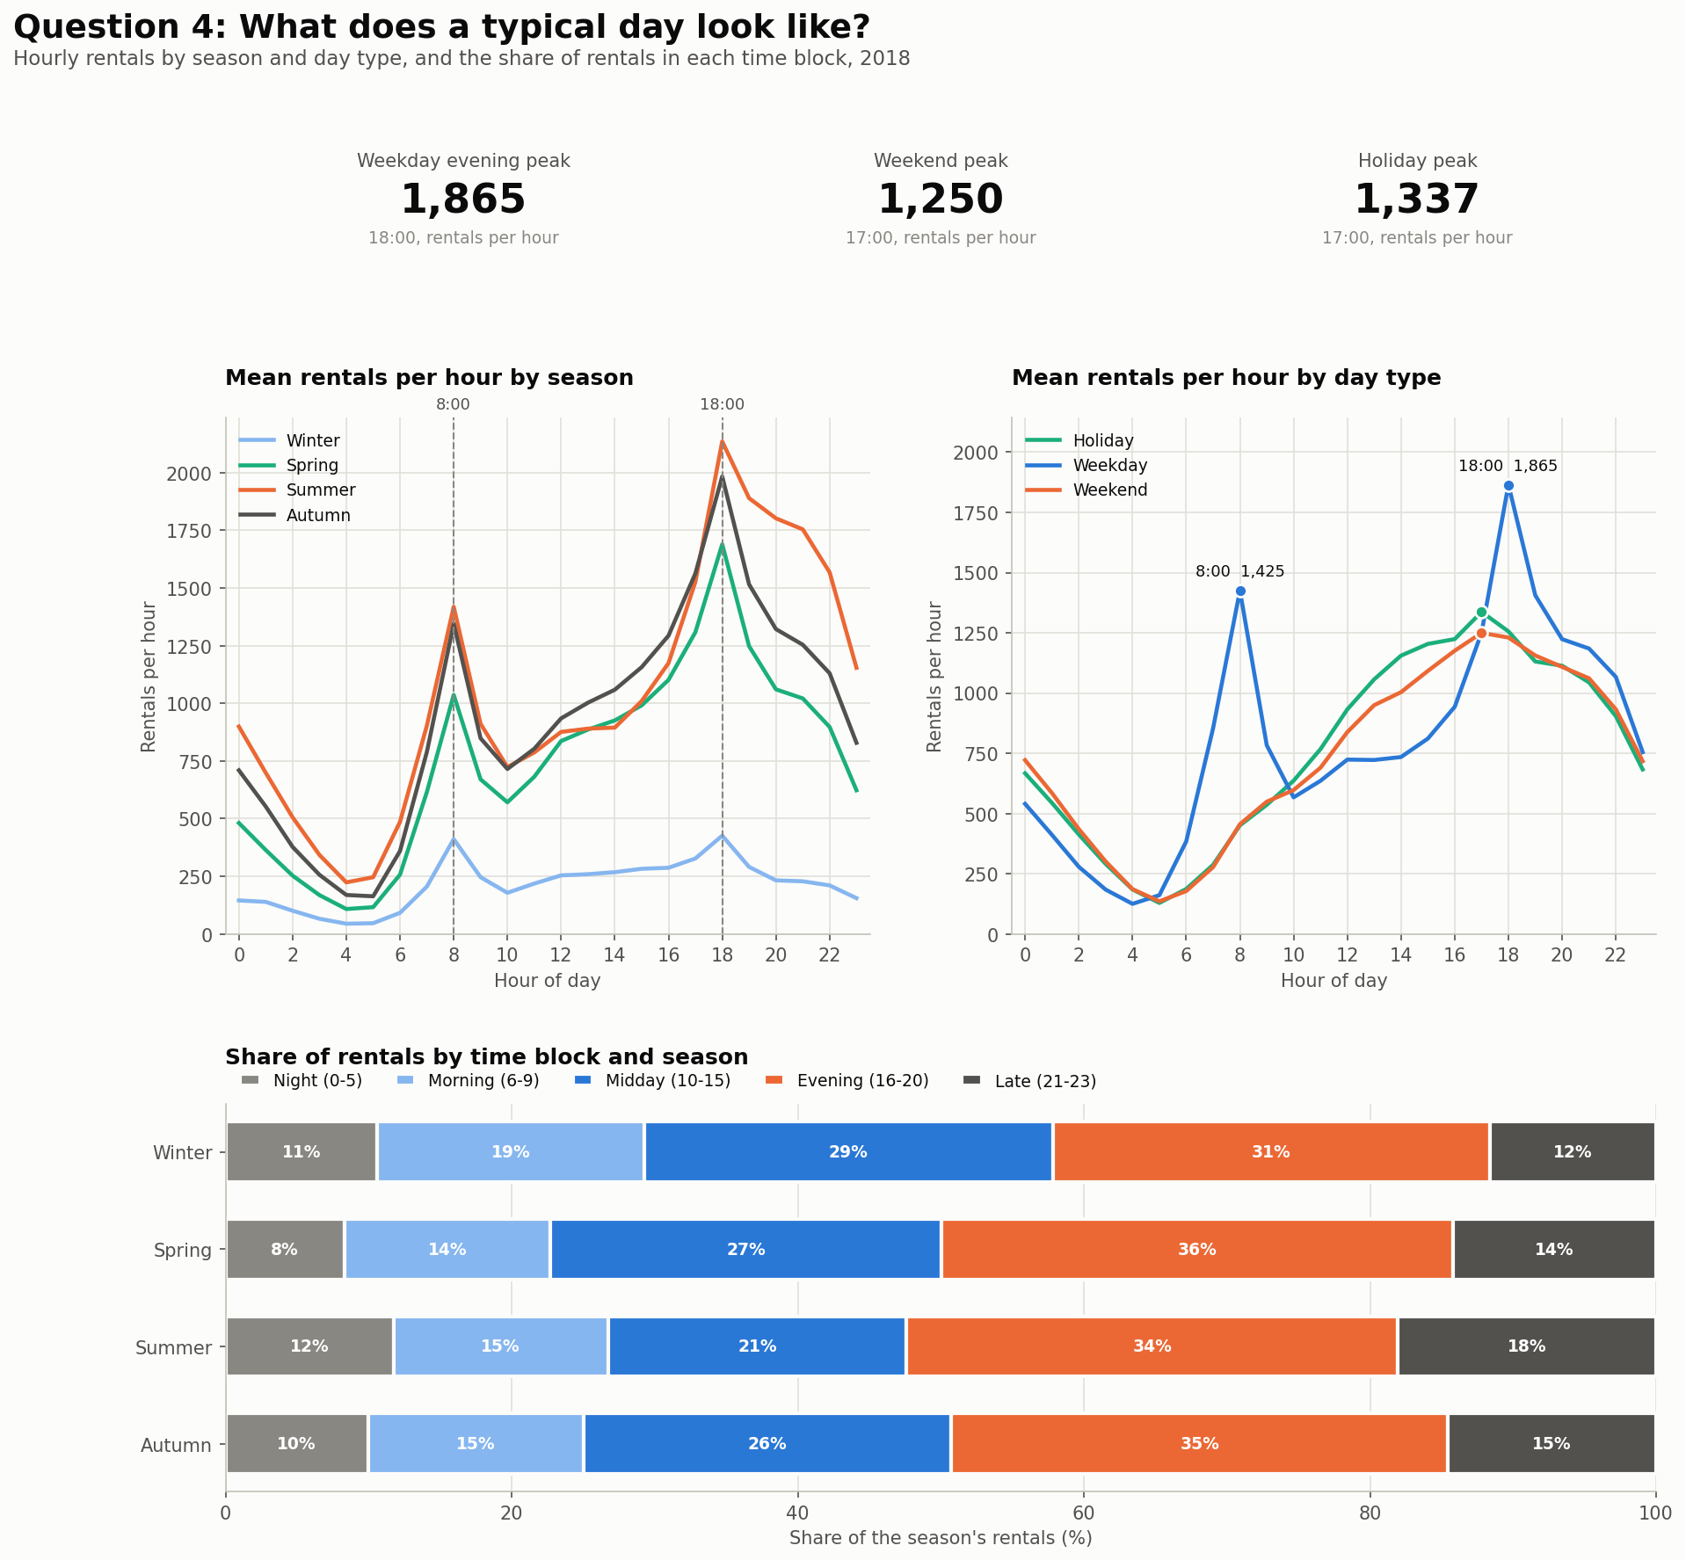
Figure 4. Rentals by hour, by season and day type, 2018.
Group | Rate at 8:00 | Rate at 11:00 | Evening peak | Rentals per hour | Quietest hour
Weekday | 1,425 | 636 | 18:00 | 1,865 | 4:00
Weekend | 456 | 690 | 17:00 | 1,250 | 5:00
Holiday | 451 | 767 | 17:00 | 1,337 | 5:00
Winter | 411 | 218 | 18:00 | 426 | 4:00
Spring | 1,036 | 681 | 18:00 | 1,689 | 4:00
Summer | 1,419 | 787 | 18:00 | 2,135 | 4:00
Autumn | 1,345 | 803 | 18:00 | 1,983 | 5:00
Table 3.3: Peak Table across, day type and season

- Weekdays show two peaks, at 8:00 with 1,425 rentals per hour and at 18:00 with 1,865. This points to commuting.

- Weekends and holidays peak once, at 17:00, with 1,250 and 1,337 rentals per hour respectively. At 8:00 the weekday rate (1,425) is 3.1 times the weekend rate (456). Weekday demand then drops to 636 at 11:00, while weekend demand keeps climbing to 690.

- All four seasons peak at 8:00 and 18:00. Summer reaches 2,135 per hour at 18:00 against 426 in Winter, 5.0 times as many.

- The evening block (16:00 to 20:00) holds the largest share of rentals in every season, 35% across the year. Spring is highest at 36%.

- Winter has the largest morning share at 19%. Summer has the largest late share at 18%.

- The holiday profile rests on 16 dates, so read its pattern with caution.

One-liner Insights: Weekdays follow a commuter pattern with a stronger evening peak. Weekends and holidays rise through the afternoon to 17:00. Season changes the size of the peaks and keeps their timing.

Question 5: How do weeks and weekdays compare?
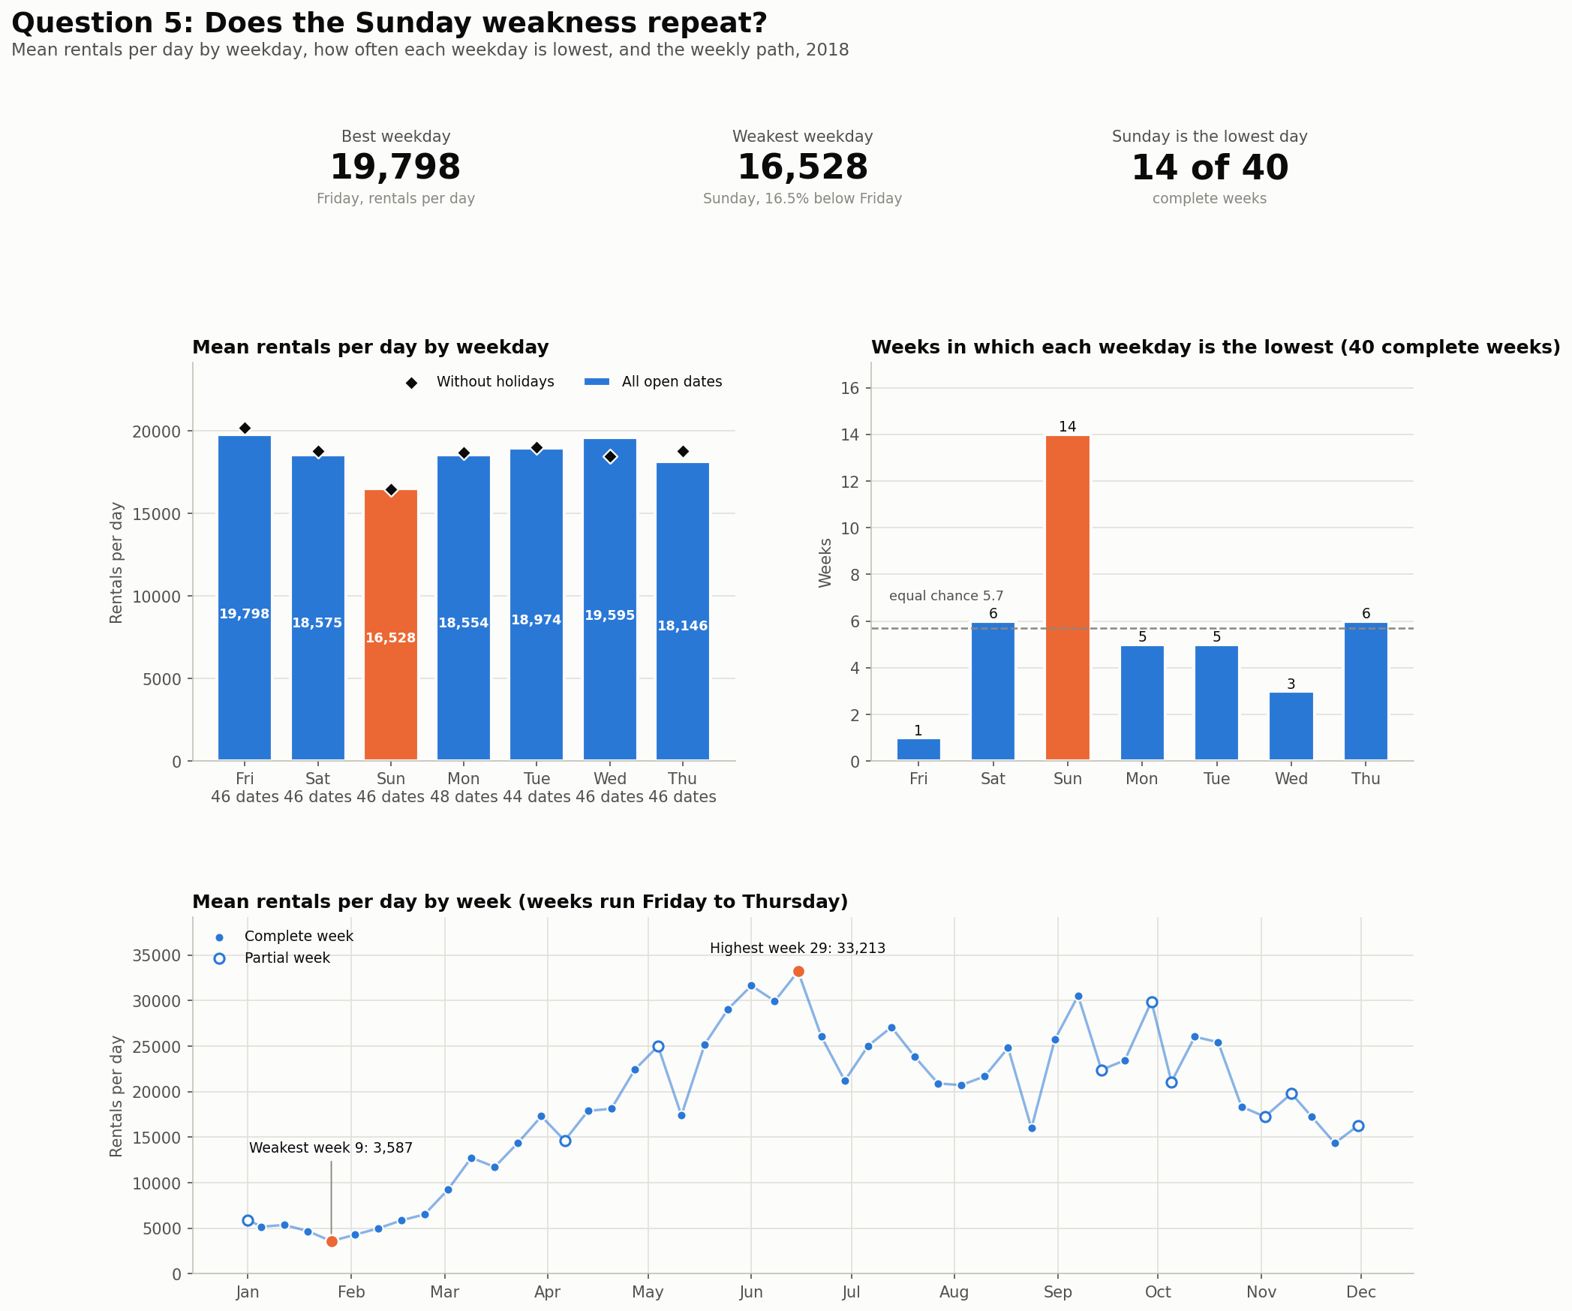
Figure 5. Weekday means, lowest day by week and weekly means, 2018.

Weekday | Open Dates | Mean per Day | Mean without Holiday | Gap to Friday | Weeks Lowest
Friday | 46 | 19,798 | 20,181 | best | 1
Saturday | 46 | 18,575 | 18,772 | −6% | 6
Sunday | 46 | 16,528 | 16,450 | −17% | 14
Monday | 48 | 18,554 | 18,686 | −6% | 5
Tuesday | 44 | 18,974 | 18,993 | −4% | 5
Wednesday | 46 | 19,595 | 18,482 | −1% | 3
Thursday | 46 | 18,146 | 18,775 | −8% | 6
Table 3.4: Weekday Table

- Friday recorded the highest weekday demand at 19,798 rentals per day. Sunday ranked last, at 16,528 with all dates and 16,450 without holidays. Sunday sits 3,270 rentals per day (16.5%) below Friday.

- Sunday is the lowest day in 14 of 40 complete weeks, against about 6 if every weekday had an equal chance.

- Excluding holidays, Wednesday's mean falls from 19,595 to 18,482. 5 of Wednesday's 46 dates are holidays, including 13 June, the busiest day. Without them Wednesday falls from second place to sixth.

- Tuesday accounts for 4 of the 12 closed dates, so its mean rests on 44 open dates. The other weekday means rest on 46 or 48.

- The Sunday weakness repeats. In December 2017 Sunday averaged 3,978 rentals per day, 33.5% below that month's mean of 5,978. Across 2018 Sunday sits 11.1% below the year's mean. Within Winter 2018 it sits 19.0% below the mean of 5,116.

- The highest complete week was Week 29 (15 Jun to 21 Jun), averaging 33,213 rentals per day. The weakest was Week 9 (26 Jan to 1 Feb), averaging 3,587. The Appendix lists every week.

One-liner Insights: Friday leads and Sunday trails, in 2018 as in December 2017. The Sunday gap is smaller across the year than inside Winter.

Question 6: Does weather explain demand inside each season?
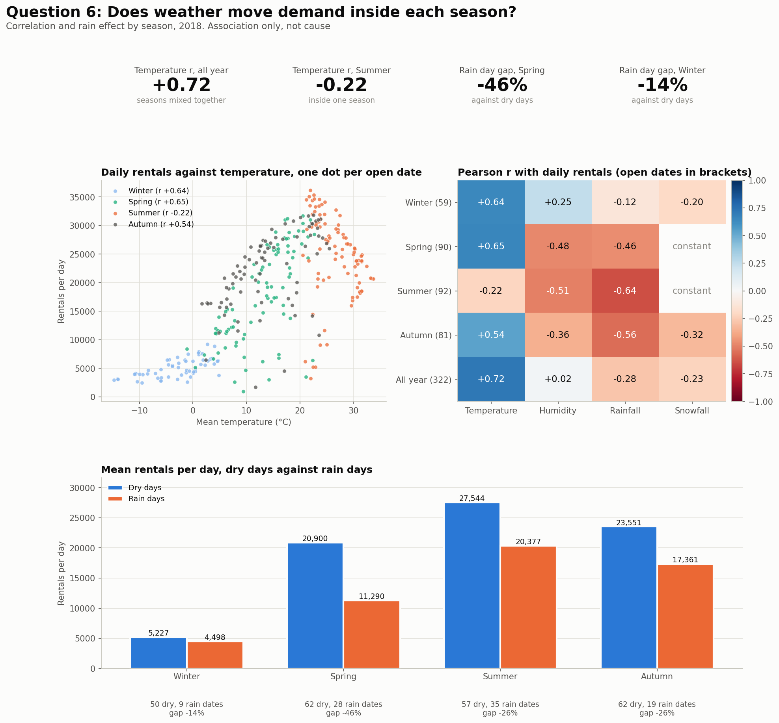
Figure 6. Weather and daily rentals by season, 2018.
Season | Open Dates | Temperature (r) | Humidity (r) | Rainfall (r) | Snowfall (r)
Winter | 59 | +0.64 | +0.25 | −0.12 | −0.20
Spring | 90 | +0.65 | −0.48 | −0.46 | constant
Summer | 92 | −0.22 | −0.51 | −0.64 | constant
Autumn | 81 | +0.54 | −0.36 | −0.56 | −0.32
All year | 322 | +0.72 | +0.02 | −0.28 | −0.23
Table 3.5: Weather Table by Season
Season | Dry Dates | Rain Dates | Dry Mean per Day | Rain Mean per Day | Gap
Winter | 50 | 9 | 5,227 | 4,498 | −14%
Spring | 62 | 28 | 20,900 | 11,290 | −46%
Summer | 57 | 35 | 27,544 | 20,377 | −26%
Autumn | 62 | 19 | 23,551 | 17,361 | −26%
Table 3.6: Seasonal Table across Dry and Rain dates

- Temperature moves demand across the year, with r = +0.72. Most of this link comes from the gap between seasons.

- Inside each season the picture changes. Temperature r is +0.64 in Winter, +0.65 in Spring and +0.54 in Autumn. In Summer it turns to −0.22, so the hottest summer days bring no extra demand.

- Rain is the clearer drag inside a season. Rainfall r is −0.64 in Summer, −0.56 in Autumn and −0.46 in Spring.

- Rain days fall below dry days by 46% in Spring (11,290 against 20,900 rentals per day), 26% in Summer, 26% in Autumn and 14% in Winter.

- Winter rain (r −0.12) and snow (r −0.20) sit below the 0.26 that 59 dates need, so Winter shows no clear link to either.

- Spring and Summer record no snow, so snow r does not exist there. Autumn snow rests on 3 dates, so its r of −0.32 should not be read.

- The three weakest dates outside Winter (23 April, 8 November and 5 April) all recorded rainfall of 10 mm or more.

- These figures show association only. Rainy days also bring humidity and clouds, and the data cannot separate them.

One-liner Insights: Temperature drives the year-round pattern but not the pattern inside Summer. Rain is the weather factor tied to lower demand in Spring, Summer and Autumn. Winter shows no clear weather link.

Question 7: How do holidays and closed dates affect demand, and how does Winter 2018 compare with December 2017?
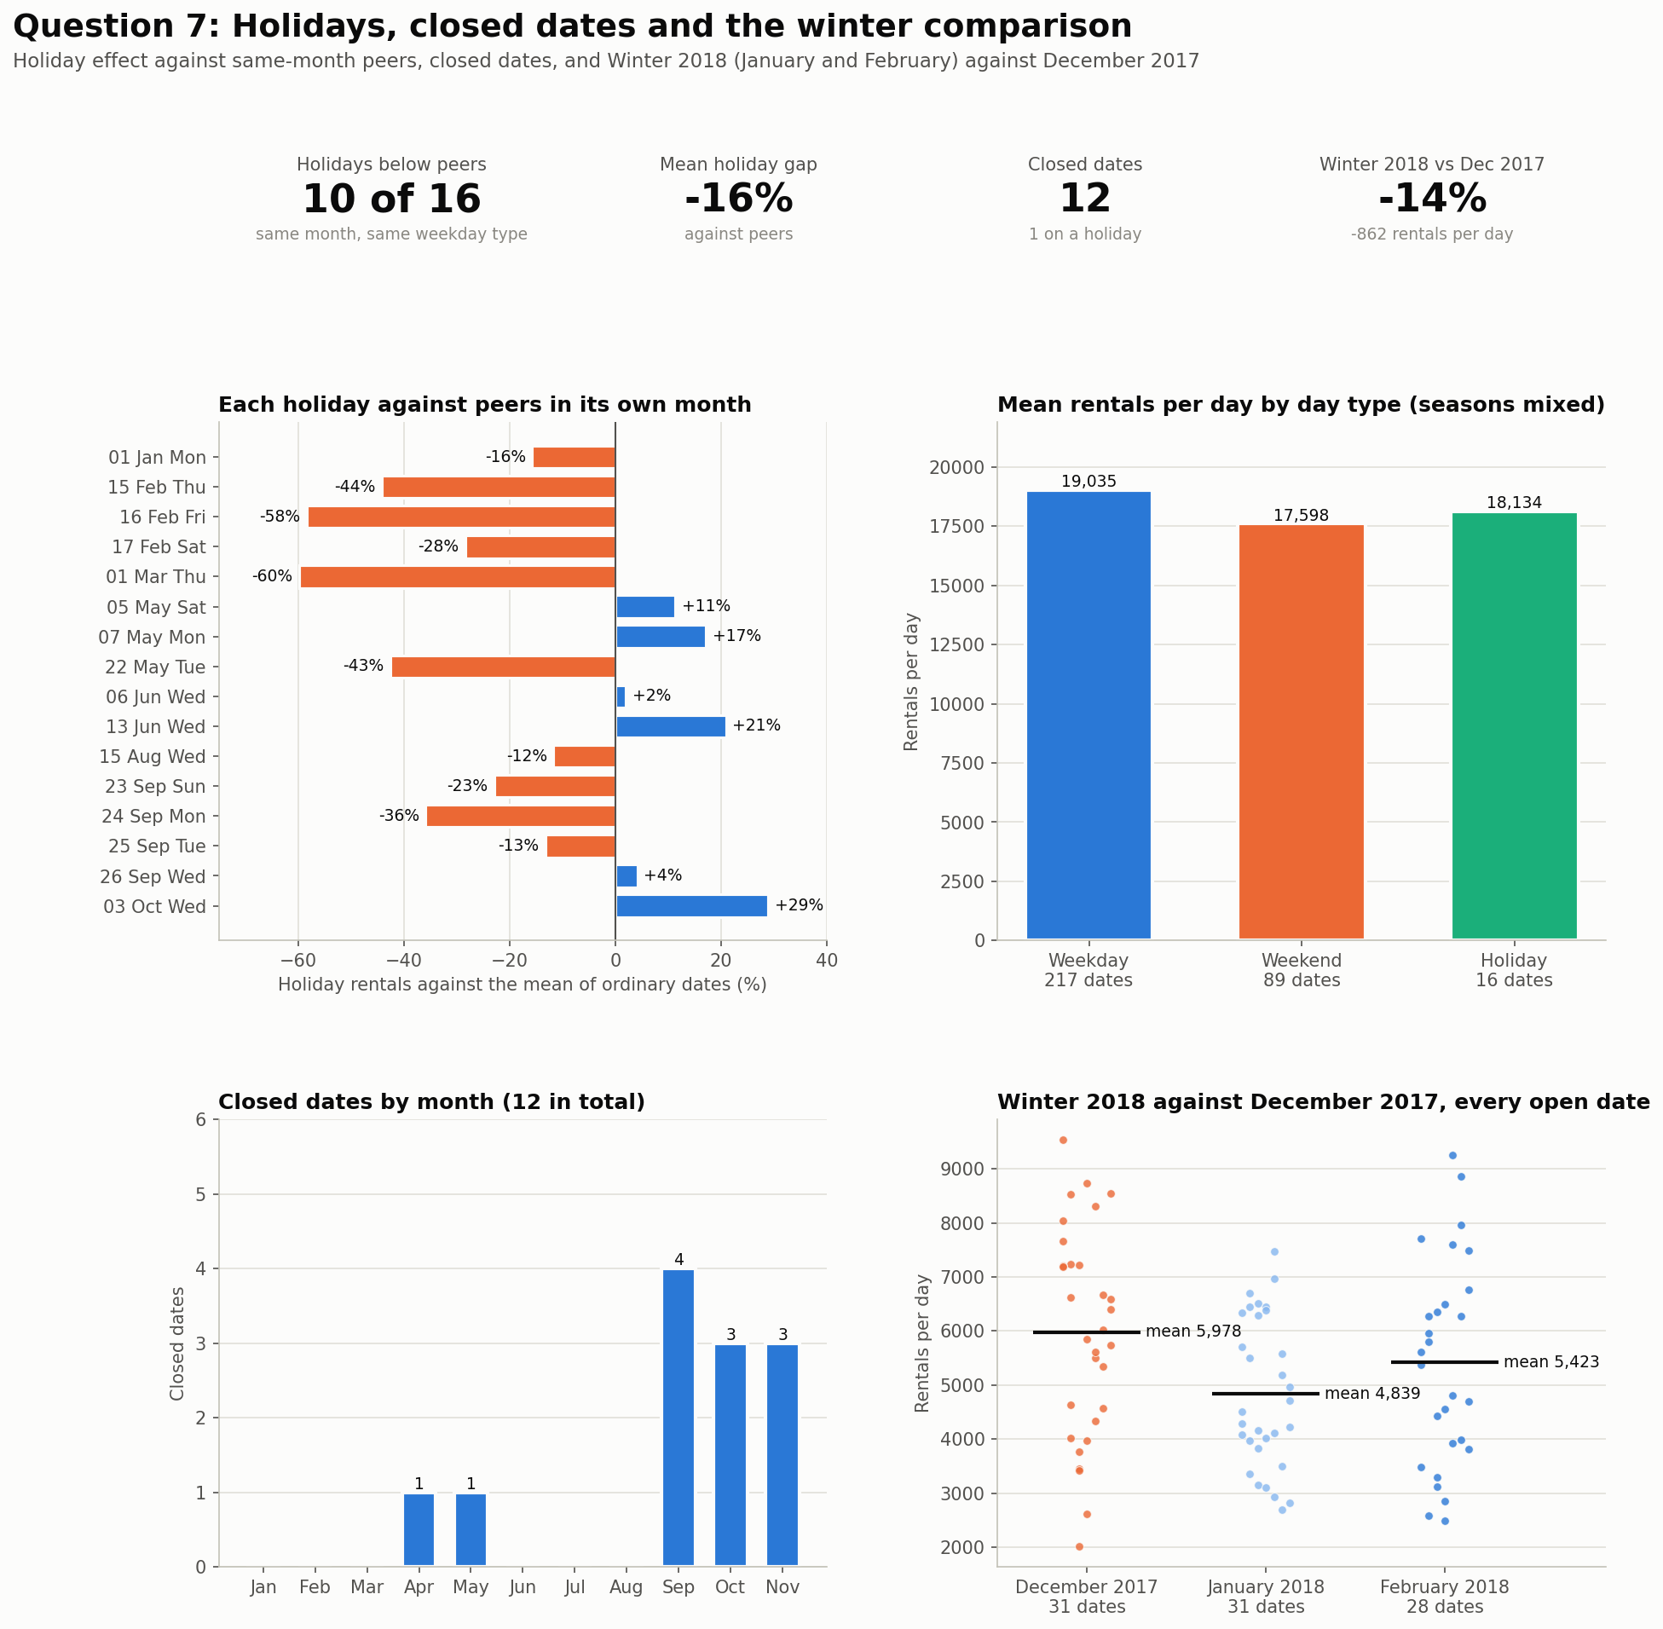
Figure 7. Holidays against peers, closed dates and the winter comparison.

Holidays
- Against ordinary dates in the same month and the same weekday type, 10 of 16 open holidays fall below. The mean gap is −15.5% and the median is −14.5%.

- The three Seollal dates sit 28% to 58% below peers. Chuseok shows the same pattern on three of four dates, then the substitute day (26 September) sits 4% above.

- Six holidays sit above peers. The strongest is 3 October at +29%. The busiest day of the year, 13 June (election day), sits 21% above.

- The raw day type means (Weekday 19,035, Weekend 17,598, Holiday 18,134) mix seasons, so they do not rank holidays fairly. The Appendix lists each holiday and its peers.

Closed Dates
Dates | Weekday | Holiday
11 April 2018 | Wednesday | No
10 May 2018 | Thursday | No
18 September 2018 | Tuesday | No
19 September 2018 | Wednesday | No
28 September 2018 | Friday | No
30 September 2018 | Sunday | No
2 October 2018 | Tuesday | No
4 October 2018 | Thursday | No
9 October 2018 | Tuesday | Yes
3 November 2018 | Saturday | No
6 November 2018 | Tuesday | No
9 November 2018 | Friday | No
Table 3.7: Closed Dates Table

- The center closed on 12 dates. 10 falls between September and November (4 in September, 3 in October, 3 in November).

- April and May hold one each.

- Tuesday accounts for 4 closures. 9 October (Hangul Day) is a verified holiday and holds no rows.

- 6 October is the only partial date, with 17 open hours.
Winter 2018 against December 2017
Period | Open Dates | Mean per Day | Median | Lowest | Highest | Temp (°C) | Snowfall (cm/day) | Holidays
December 2017 | 31 | 5,978 | 6,019 | 2,014 | 9,539 | −1.9 | 8.9 | 1
January 2018 | 31 | 4,839 | 4,503 | 2,693 | 7,472 | −3.9 | 6.1 | 1
February 2018 | 28 | 5,423 | 5,495 | 2,487 | 9,247 | −1.7 | 2.4 | 3
Winter 2018 | 59 | 5,116 | 4,813 | 2,487 | 9,247 | −2.9 | 4.4 | 4
Table 3.8: Comparison Table

- Winter 2018 averages 5,116 rentals per day against 5,978 in December 2017. That is 862 fewer, a gap of 14.4%.

- January averages 4,839 (19.1% below December) and February 5,423 (9.3% below).

- The gap is 2.1 standard errors wide, so it is borderline. The standard error is about 411 rentals per day. It combines the day-to-day swing in December (standard deviation 1,943 over 31 dates) and in Winter (1,675 over 59 dates). The gap of 862 divided by 411 gives 2.1. A value near 2 is the usual line for telling a real difference from chance.

- December 2017 was not milder. It held more snow (8.9 cm per day against 4.4) and a similar temperature (−1.9 C against −2.9 C), yet demand ran higher. Weather does not explain the gap.

- Winter holds 4 holidays, 3 of them Seollal days that sit 28% to 58% below peers. December holds 1.

- Sunday stays weak in both periods, 33.5% below the December mean and 19.0% below the Winter mean.

- One December and one winter cannot separate a seasonal change from a trend in the business.

One-liner Insights: Holidays do not lift demand. Most fall below ordinary dates in their month. Winter 2018 runs 14% below December 2017, and weather does not explain the gap.

Data Limitations
- One year. The report covers January to November 2018. A second year is needed to separate a seasonal pattern from a trend.

- Winter is thin. Winter 2018 holds January and February only. December 2018 is not in the data.

- Closed dates. The 12 closed dates carry no rentals and no reason. Month, week and weekday means rest on fewer dates where closures fall.

- Partial date. 6 October holds 17 open hours, so its daily total sits slightly low.

- No operations records. The file holds no bike availability, repair, fleet or station data. Supply-side causes stay untested.

- No money data. The file holds no revenue or cost figures.

- Weather is a daily summary. Daily means and totals hide the hour when rain fell. A morning shower and an evening storm look the same.

- Association only. Correlations are straight-line measures on adjacent dates, which are not independent. They do not prove cause. A rain day also brings humidity and clouds.

- Holiday set. The 16 open holidays and the closed holiday come from one published calendar and a manual check. The source flag in the data is not used. Seollal and Chuseok dates have few peers.

- Winter comparison. December 2017 is one month, and Winter 2018 is two different months. The gap is borderline.

Business Recommendations
Recommendation 1: Review the records behind the 12 closed dates and the lowest days
Finding. The center closed on 12 dates and 10 of them fall between September and November. 23 April (977 rentals) and 8 November (1,721) were the two quietest open dates and both recorded heavy rains. The data gives no reason for any closure.
Action. Match each closed date and the five quietest open dates to maintenance logs, staffing records and system outage records. Separate weather closures from planned or technical ones.
Expected result. The company learns whether the autumn closures were planned or avoidable and decides whether to change service or schedule.
Data gap. The data confirms when the center closed and holds no cause.

Recommendation 2: Protect the weekday commuter peaks
Finding. Weekday rentals peak at 8:00 (1,425 per hour) and 18:00 (1,865). The evening block holds 35% of all rentals. In Summer the 18:00 rate reaches 2,135 per hour.
Action. Stock bikes at stations before 8:00 and 17:00 on weekdays. Keep servicing out of 7:00 to 9:00 and 17:00 to 19:00, most of all from May to October.
Expected result. The company tracks unavailable bikes in these windows and compares them with rentals.
Data gap. Rentals count completed trips only, so unmet demand stays hidden. The file holds no station data.

Recommendation 3: Place routine service in the low-demand windows
Finding. Sunday is the lowest day in 14 of 40 complete weeks and averages 16,528 rentals per day against 19,798 on Friday. Rain days run 26% to 46% below dry days in Spring, Summer and Autumn. Winter averages 5,116 per day. Most Seollal and Chuseok dates ran below peers.
Action. Schedule routine servicing and repairs on Sundays, on forecast rain days and over the Seollal and Chuseok holidays. Book longer fleet work in January and February.
Expected result. The company compares repair downtime and rentals before and after the new service windows over several weeks.
Data gap. Sunday and rain findings rest on association. The file holds no repair, fleet or cost records.

Recommendation 4: Record the data the 2018 analysis could not see
Finding. Winter 2018 runs 14.4% below December 2017, and weather does not explain the gap. The data holds no availability, closure reason, station or unmet-demand record.
Action. Log closure reasons, bike availability by station and failed rental attempts from now on. Add December 2018 and 2019 to the analysis when available.
Expected result. The next report tests whether the winter gap is seasonal or a trend and measures demand left unserved.
Data gap. Until these records exist the report describes what happened and cannot say why.

Conclusion
Seoul Bike Rentals saw 5,986,984 rentals in 2018 from January to November. Season sets the level of demand. Summer averages 24,818 rentals per day and Winter 5,116. Weekdays follow a commuter pattern with peaks at 8:00 and 18:00. Friday leads and Sunday trails. Inside a season, rain days run 14% to 46% below dry days, and temperature loses its link in Summer.
Holidays do not lift demand, and the center’s 12 closures carry no recorded reason. Winter 2018 runs 14.4% below December 2017, and weather does not explain the gap. The data shows what happened and does not show why. The four recommendations test causes before the company acts.

Appendix
- Holidays against peers
Holiday | Weekday | Rentals | Peer Dates | Peer Mean | Gap
1 Jan 2018 | Monday | 4,290 | 22 | 5,092 | −15.8%
15 Feb 2018 | Thursday | 3,484 | 18 | 6,232 | −44.1%
16 Feb 2018 | Friday | 2,593 | 18 | 6,232 | −58.4%
17 Feb 2018 | Saturday | 3,118 | 7 | 4,353 | −28.4%
1 Mar 2018 | Thursday | 5,132 | 21 | 12,773 | −59.8%
5 May 2018 | Saturday | 25,353 | 7 | 22,771 | +11.3%
7 May 2018 | Monday | 28,140 | 20 | 24,020 | +17.2%
22 May 2018 | Tuesday | 13,790 | 20 | 24,020 | −42.6%
6 Jun 2018 | Wednesday | 30,498 | 19 | 29,907 | +2.0%
13 Jun 2018 | Wednesday | 36,149 | 19 | 29,907 | +20.9%
15 Aug 2018 | Wednesday | 18,565 | 22 | 21,022 | −11.7%
23 Sep 2018 | Sunday | 20,060 | 8 | 26,020 | −22.9%
24 Sep 2018 | Monday | 17,259 | 14 | 26,912 | −35.9%
25 Sep 2018 | Tuesday | 23,350 | 14 | 26,912 | −13.2%
26 Sep 2018 | Wednesday | 28,018 | 14 | 26,912 | +4.1%
3 Oct 2018 | Wednesday | 30,349 | 19 | 23,555 | +28.8%
Table 3.9: Holiday against their peer’s table

- Weekly means
Week | Dates | Days | Mean per Day | Change | Note
5 | 1 Jan to 4 Jan | 4 | 5,925 | n/a | Partial
6 | 5 Jan to 11 Jan | 7 | 5,179 | −13% | Full
7 | 12 Jan to 18 Jan | 7 | 5,365 | +4% | Full
8 | 19 Jan to 25 Jan | 7 | 4,682 | −13% | Full
9 | 26 Jan to 1 Feb | 7 | 3,587 | −23% | Full
10 | 2 Feb to 8 Feb | 7 | 4,280 | +19% | Full
11 | 9 Feb to 15 Feb | 7 | 4,983 | +16% | Full
12 | 16 Feb to 22 Feb | 7 | 5,862 | +18% | Full
13 | 23 Feb to 1 Mar | 7 | 6,531 | +11% | Full
14 | 2 Mar to 8 Mar | 7 | 9,256 | +42% | Full
15 | 9 Mar to 15 Mar | 7 | 12,751 | +38% | Full
16 | 16 Mar to 22 Mar | 7 | 11,736 | −8% | Full
17 | 23 Mar to 29 Mar | 7 | 14,388 | +23% | Full
18 | 30 Mar to 5 Apr | 7 | 17,304 | +20% | Full
19 | 6 Apr to 12 Apr | 6 | 14,642 | −15% | Partial
20 | 13 Apr to 19 Apr | 7 | 17,894 | +22% | Full
21 | 20 Apr to 26 Apr | 7 | 18,132 | +1% | Full
22 | 27 Apr to 3 May | 7 | 22,415 | +24% | Full
23 | 4 May to 9 May | 6 | 25,007 | +12% | Partial
24 | 11 May to 17 May | 7 | 17,401 | −30% | Full
25 | 18 May to 24 May | 7 | 25,199 | +45% | Full
26 | 25 May to 31 May | 7 | 29,079 | +15% | Full
27 | 1 Jun to 7 Jun | 7 | 31,652 | +9% | Full
28 | 8 Jun to 14 Jun | 7 | 29,957 | −5% | Full
29 | 15 Jun to 21 Jun | 7 | 33,213 | +11% | Full
30 | 22 Jun to 28 Jun | 7 | 26,051 | −22% | Full
31 | 29 Jun to 5 Jul | 7 | 21,215 | −19% | Full
32 | 6 Jul to 12 Jul | 7 | 25,032 | +18% | Full
33 | 13 Jul to 19 Jul | 7 | 27,095 | +8% | Full
34 | 20 Jul to 26 Jul | 7 | 23,843 | −12% | Full
35 | 27 Jul to 2 Aug | 7 | 20,906 | −12% | Full
36 | 3 Aug to 9 Aug | 7 | 20,725 | −1% | Full
37 | 10 Aug to 16 Aug | 7 | 21,700 | +5% | Full
38 | 17 Aug to 23 Aug | 7 | 24,822 | +14% | Full
39 | 24 Aug to 30 Aug | 7 | 15,991 | −36% | Full
40 | 31 Aug to 6 Sep | 7 | 25,713 | +61% | Full
41 | 7 Sep to 13 Sep | 7 | 30,546 | +19% | Full
42 | 14 Sep to 20 Sep | 5 | 22,406 | −27% | Partial
43 | 21 Sep to 27 Sep | 7 | 23,449 | +5% | Full
44 | 29 Sep to 3 Oct | 3 | 29,902 | +28% | Partial
45 | 5 Oct to 11 Oct | 6 | 21,078 | −30% | Partial
46 | 12 Oct to 18 Oct | 7 | 26,041 | +24% | Full
47 | 19 Oct to 25 Oct | 7 | 25,436 | −2% | Full
48 | 26 Oct to 1 Nov | 7 | 18,367 | −28% | Full
49 | 2 Nov to 8 Nov | 5 | 17,253 | −6% | Partial
50 | 10 Nov to 15 Nov | 6 | 19,802 | +15% | Partial
51 | 16 Nov to 22 Nov | 7 | 17,283 | −13% | Full
52 | 23 Nov to 29 Nov | 7 | 14,342 | −17% | Full
53 | 30 Nov | 1 | 16,297 | +14% | Partial

